Purpose
This dashboard was created for my client, Grazioso Salvare, to help identify dogs from the Austin Animal Center that may be suitable for specialized training. The application connects to a MongoDB database that contains the animal shelter's records and provides an interactive, web-based dashboard for filtering, viewing, and visualizing the data through a bar graph.
Required Functionality
- Grazioso salvare logo must be displayed with a hyperlink to the client’s web page.
- A unique identifier to credit the creator of the dashboard
- Interactive filtering options:
- Reset - displays the complete, unfiltered database
- Water Rescue - identifies dogs that qualify for water rescue training based on specific breeds, sex, and training age range
- Mountain or Wilderness Rescue - identifies dogs that qualify for mountain or rescue training based on specific breeds, sex, and training age range
- Disaster Rescue or Individual Tracking - identifies dogs that qualify for disaster rescue training or individual tracking training based on specific breeds, sex, and training age range
- Display filtered results in an interactive data table
- Display a geolocation map based on selected animal’s latitude and longitude
- Display a breeds bar chart that dynamically updates based on current filtered data
- Allow table to be filtered, sorted, and paginated
- Allow users to select a single row from the data table
- Must be user-friendly and intuitive
Tools
MongoDB
This was used as the model component of the development because it provides a flexible document-oriented data model that works well with the structure of the Austin Animal Center’s records. Each animal is stored as a document containing fields such as animal type, breed, name, age, sex, outcome information, and geographic coordinates. The AAC’s dataset was imported into MongoDB and stored in the animals collection within the aac database.
PyMongo
This library allows the Python application to establish a connection to MongoDB and perform CRUD operations via Python Methods. This made it possible for CRUD_Python_Module to retrieve the shelter data and then provide it to the dashboard.
Python
Python was the primary programming language for this project. It bridges the connection between the MongoDB aac database and the Dash dashboard. Python was selected because it has useful libraries for database access, data manipulation and visualization, and web application development.

Dash
Dash was used to create the web-based dashboard and provide the application’s view and controller structure. The view was created using components such as dcc.Graph for the graph element and html.Div for the style of the web page itself.
The application’s controller behavior is implemented through Dash callbacks. Callbacks connect dashboard inputs to output and allow the interface to react dynamically when the user uses a filter or selects a row. When the user selects a rescue category, the callback filters the data and updates the DataTable, then the bar chart and geographic location map update in response to the new data.
JupyterDash
JupyterDash was used to run the Dash application directly from the Jupyter Notebook environment. This was especially helpful because the whole project was centralized within the same notebook, so it made development and testing easier.
Plotly
Plotly was used to create the dashboard’s interactive bar chart. The chart displays the most common breeds by filter type. This chart is able to respond dynamically to filtering options because it receives the data currently displayed by the dashboard, calculates breed counts using Pandas, then updates to reflect the new data.

Dash Leaflet
Dash Leaflet was used to provide the dashboard’s geolocation component. The AAC dataset contains location_lat and location_long fields, allowing the selected animal's location to be displayed on an interactive geolocation chart. A map marker is generated using the selected animal’s latitude and longitude. The map marker is updated if a different animal is selected.
HTML
HTML was required in order to display the client’s logo and include a URL anchor tag with the client’s home page.
Screenshots
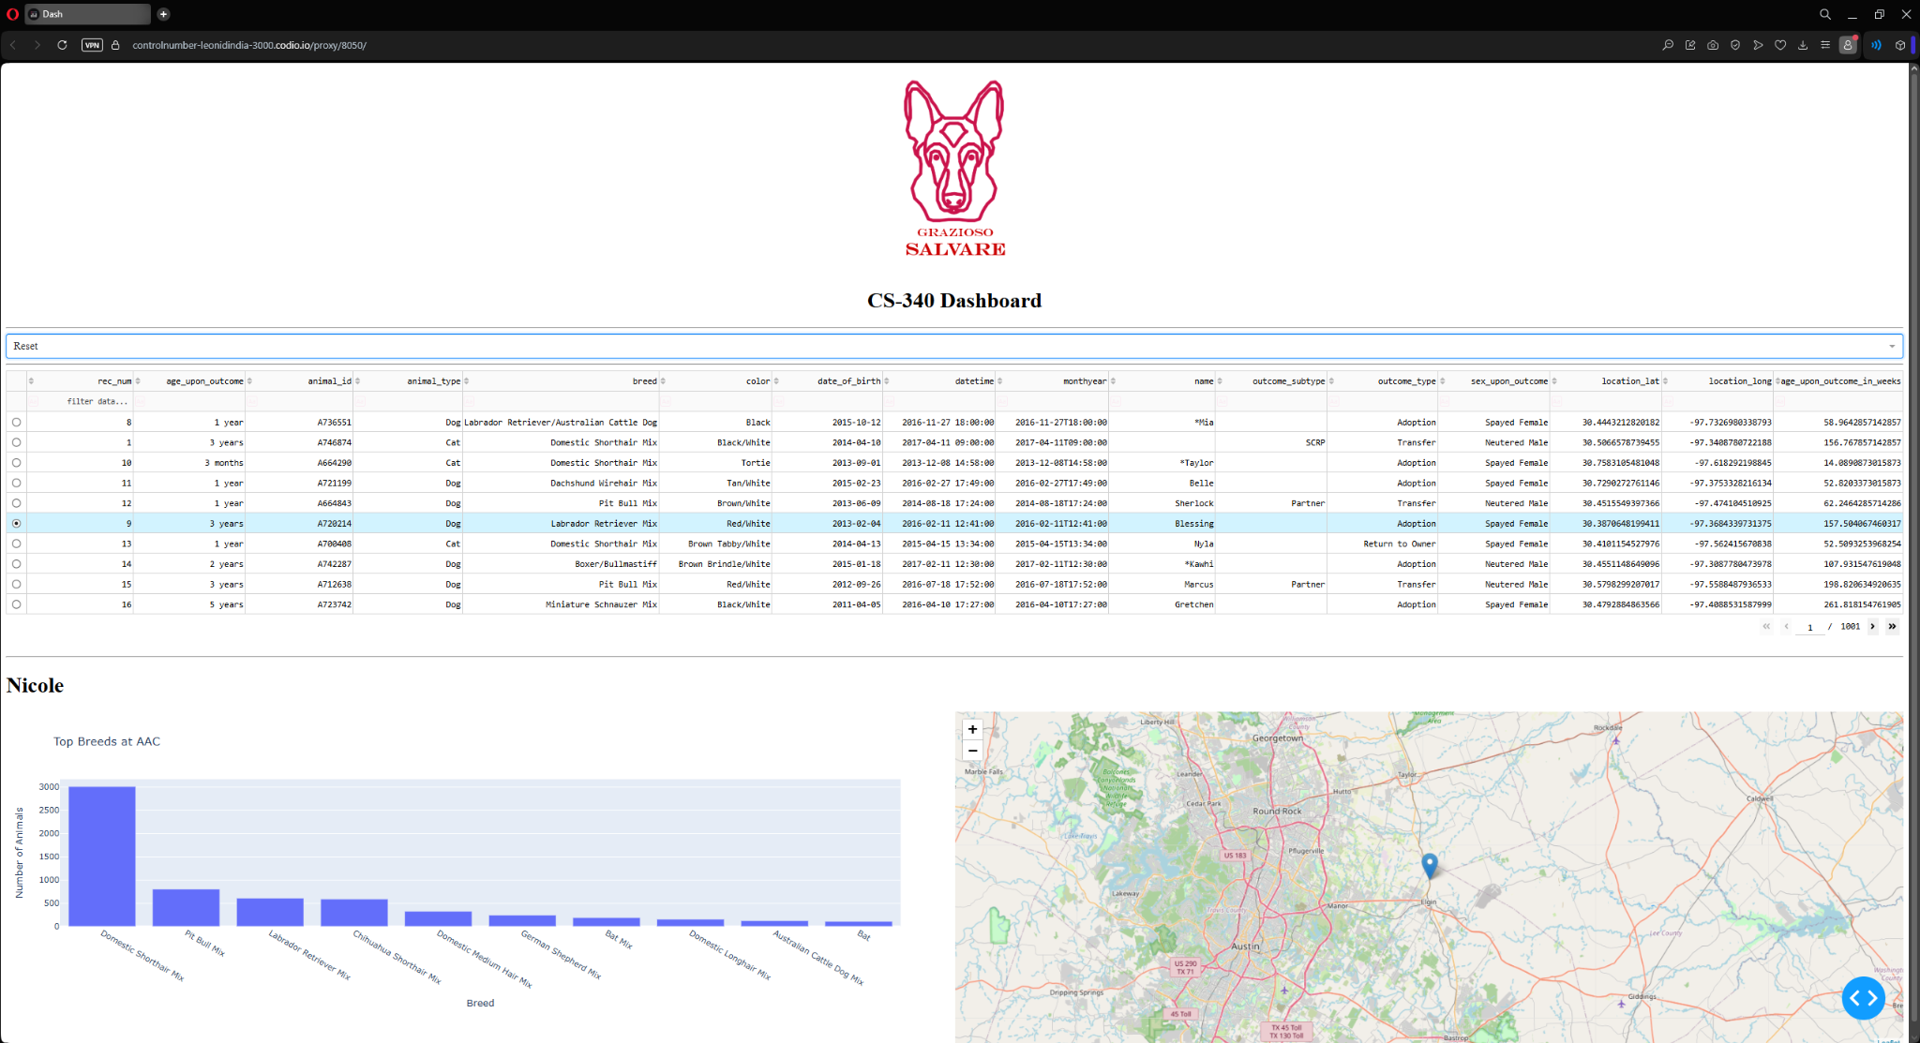
(reset filter [default view])
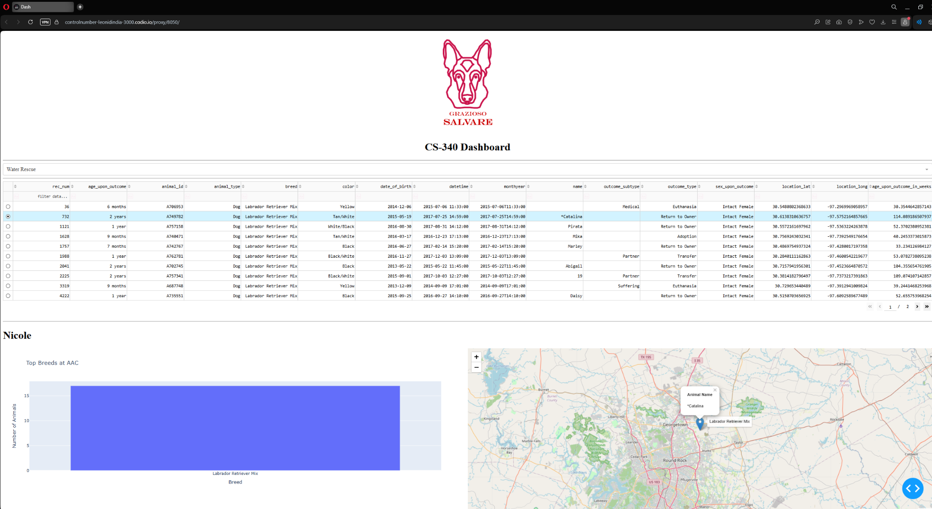(water rescue filter)
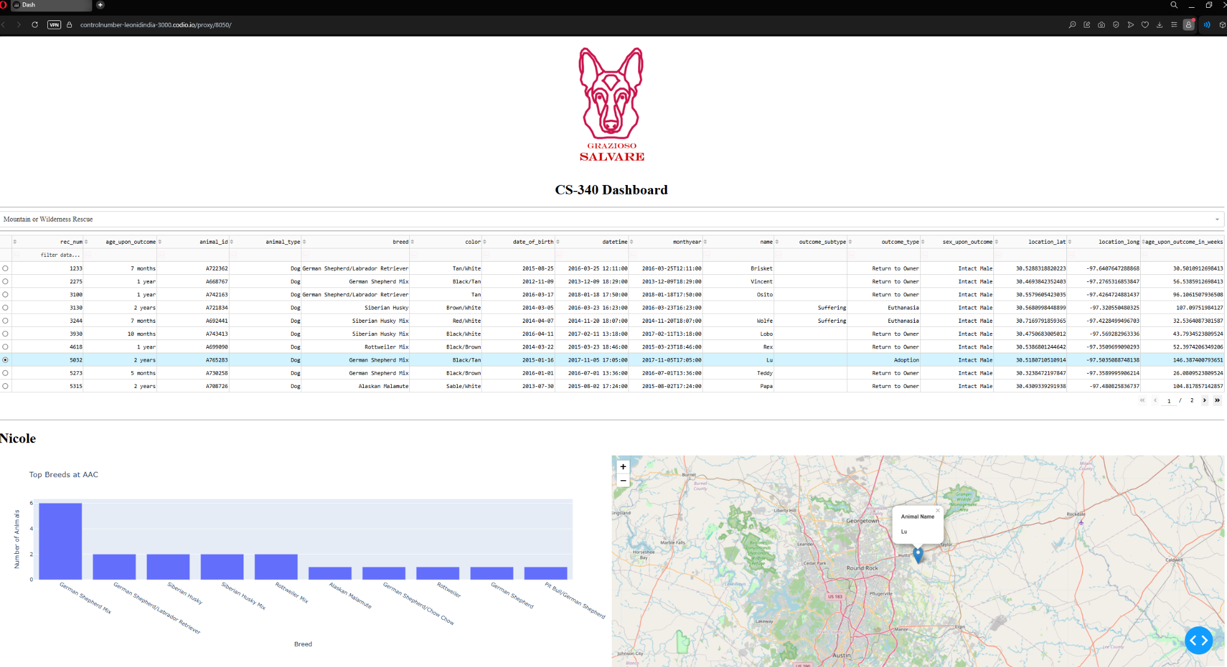
(mountain or wilderness rescue filter)

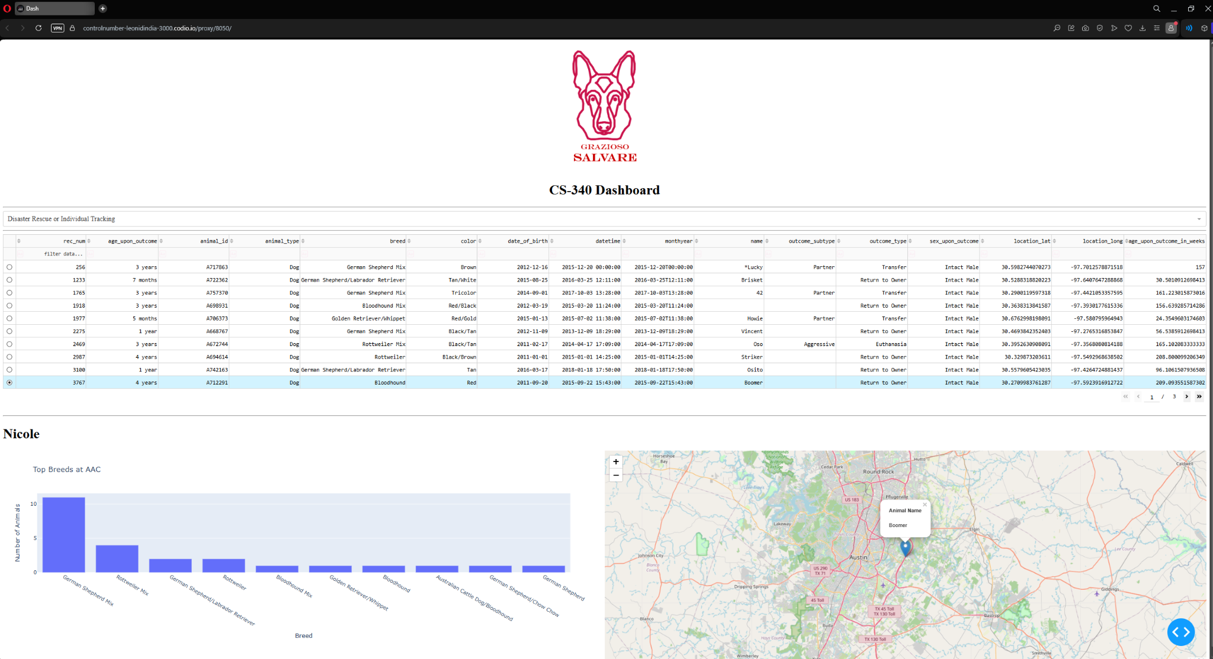
(disaster rescue or individual tracking filter)

